Project Title: NEXUS AI – Intelligent Research Workspace & Admin Control
(Basic HTML, Hyperlink and Commenting code) [Font Cambria size 12]

- JS Validation:

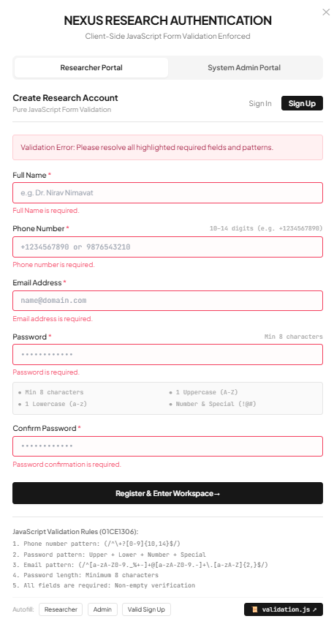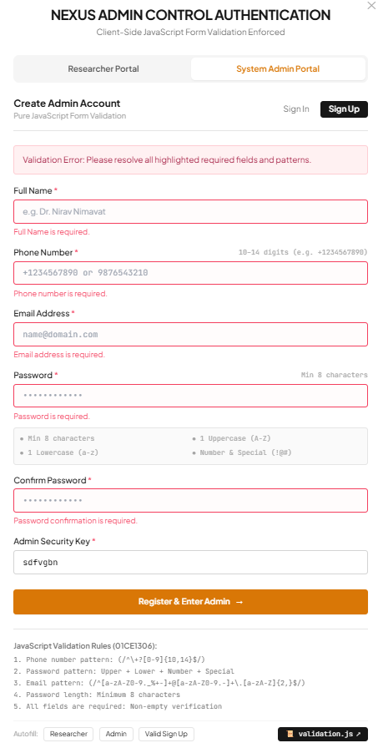

Fig 1.1 JS Validation: All fields are required

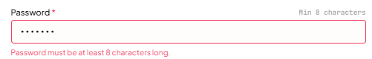
Fig 1.2 JS Validation: Password Length

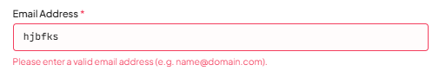

Fig 1.3 JS Validation: Email Pattern

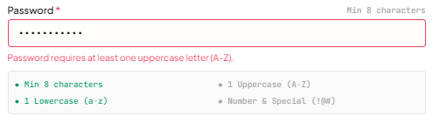

Fig 1.4 JS Validation: Password Pattern

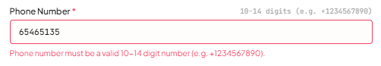

Fig 1.5 JS Validation: Phone number pattern

Source Code:

/**
* ==============================================================================
* NEXUS AI – Intelligent Research Workspace & Admin Control
* Course: Web Technology (01CE1306)
* Student Name: Nirav Nimavat (Enrollment No: 92610103001)
*
* FILE: validation.js
* PURPOSE: Pure JavaScript Form Validation for Dual-Sided Authentication
* (Researcher Portal & Admin Control Portal)
* ==============================================================================
*
* THE 5 MANDATORY JAVASCRIPT VALIDATIONS IMPLEMENTED IN THIS FILE:
* 1. Phone number pattern (/^\+?[0-9]{10,14}$/)
* 2. Password pattern (At least 1 Uppercase, 1 Lowercase, 1 Number, 1 Special Char)
* 3. Email pattern (/^[a-zA-Z0-9._%+-]+@[a-zA-Z0-9.-]+\.[a-zA-Z]{2,}$/)
* 4. Password length (Minimum 8 characters)
* 5. All fields are required (Non-empty verification)
* ==============================================================================
*/

// ==============================================================================
// 1. REGEX PATTERNS DEFINITION
// ==============================================================================
const VALIDATION_PATTERNS = {
// Rule 1: 10 to 14 digits, optional leading '+' for international format
PHONE: /^\+?[0-9]{10,14}$/,

// Rule 2: Pattern components for strong password security
PASSWORD_UPPERCASE: /[A-Z]/,
PASSWORD_LOWERCASE: /[a-z]/,
PASSWORD_NUMBER: /[0-9]/,
PASSWORD_SPECIAL: /[!@#$%^&*(),.?":{}|<>_~-]/,

// Rule 3: Standard RFC compliant email regex pattern
EMAIL: /^[a-zA-Z0-9._%+-]+@[a-zA-Z0-9.-]+\.[a-zA-Z]{2,}$/,

// Rule 4: Minimum length threshold
PASSWORD_MIN_LENGTH: 8,
};

// ==============================================================================
// 2. CORE VALIDATION FUNCTIONS
// ==============================================================================

/**
* RULE 1: Phone number pattern validation
* @param {string} phone - Input phone number
* @returns {{ isValid: boolean, message: string }}
*/
function validatePhoneNumber(phone) {
if (!phone || typeof phone !== 'string') {
return {
isValid: false,
rule: 'RULE_1_PHONE_PATTERN',
message: 'Phone number is required.'
};
}

// Strip common visual formatting characters (spaces, dashes, parentheses)
const cleanPhone = phone.replace(/[-.\s()]/g, '');

if (cleanPhone.length === 0) {
return {
isValid: false,
rule: 'RULE_5_REQUIRED',
message: 'Phone number is required.'
};
}

if (!VALIDATION_PATTERNS.PHONE.test(cleanPhone)) {
return {
isValid: false,
rule: 'RULE_1_PHONE_PATTERN',
message: 'Phone number must be a valid 10 to 14 digit number (e.g. +1234567890 or 9876543210).'
};
}

return {
isValid: true,
rule: 'RULE_1_PHONE_PATTERN',
message: ''
};
}

/**
* RULE 2: Password pattern validation
* Requires at least: 1 uppercase, 1 lowercase, 1 number, and 1 special character.
* @param {string} password - Input password
* @returns {{ isValid: boolean, message: string }}
*/
function validatePasswordPattern(password) {
if (!password) {
return {
isValid: false,
rule: 'RULE_2_PASSWORD_PATTERN',
message: 'Password pattern verification required.'
};
}

if (!VALIDATION_PATTERNS.PASSWORD_UPPERCASE.test(password)) {
return {
isValid: false,
rule: 'RULE_2_PASSWORD_PATTERN',
message: 'Password requires at least one uppercase letter (A-Z).'
};
}

if (!VALIDATION_PATTERNS.PASSWORD_LOWERCASE.test(password)) {
return {
isValid: false,
rule: 'RULE_2_PASSWORD_PATTERN',
message: 'Password requires at least one lowercase letter (a-z).'
};
}

if (!VALIDATION_PATTERNS.PASSWORD_NUMBER.test(password)) {
return {
isValid: false,
rule: 'RULE_2_PASSWORD_PATTERN',
message: 'Password requires at least one number (0-9).'
};
}

if (!VALIDATION_PATTERNS.PASSWORD_SPECIAL.test(password)) {
return {
isValid: false,
rule: 'RULE_2_PASSWORD_PATTERN',
message: 'Password requires at least one special character (!@#$%^&*).'
};
}

return {
isValid: true,
rule: 'RULE_2_PASSWORD_PATTERN',
message: ''
};
}

/**
* RULE 3: Email pattern validation
* @param {string} email - Input email address
* @returns {{ isValid: boolean, message: string }}
*/
function validateEmail(email) {
if (!email || typeof email !== 'string') {
return {
isValid: false,
rule: 'RULE_3_EMAIL_PATTERN',
message: 'Email address is required.'
};
}

const trimmedEmail = email.trim();

if (trimmedEmail.length === 0) {
return {
isValid: false,
rule: 'RULE_5_REQUIRED',
message: 'Email address is required.'
};
}

if (!VALIDATION_PATTERNS.EMAIL.test(trimmedEmail)) {
return {
isValid: false,
rule: 'RULE_3_EMAIL_PATTERN',
message: 'Please enter a valid email address format (e.g. name@domain.com).'
};
}

return {
isValid: true,
rule: 'RULE_3_EMAIL_PATTERN',
message: ''
};
}

/**
* RULE 4: Password length validation
* @param {string} password - Input password
* @param {number} minLength - Minimum length threshold (default: 8)
* @returns {{ isValid: boolean, message: string }}
*/
function validatePasswordLength(password, minLength = VALIDATION_PATTERNS.PASSWORD_MIN_LENGTH) {
if (!password || typeof password !== 'string') {
return {
isValid: false,
rule: 'RULE_4_PASSWORD_LENGTH',
message: 'Password is required.'
};
}

if (password.length < minLength) {
return {
isValid: false,
rule: 'RULE_4_PASSWORD_LENGTH',
message: `Password length must be at least ${minLength} characters.`
};
}

if (password.length > 64) {
return {
isValid: false,
rule: 'RULE_4_PASSWORD_LENGTH',
message: 'Password length cannot exceed 64 characters.'
};
}

return {
isValid: true,
rule: 'RULE_4_PASSWORD_LENGTH',
message: ''
};
}

/**
* RULE 5: Required field validation (Non-empty verification)
* @param {string} value - Value of field
* @param {string} fieldName - Human readable name of field
* @returns {{ isValid: boolean, message: string }}
*/
function validateRequired(value, fieldName = 'This field') {
if (value === undefined || value === null) {
return {
isValid: false,
rule: 'RULE_5_REQUIRED',
message: `${fieldName} is required.`
};
}

const stringVal = String(value).trim();

if (stringVal.length === 0) {
return {
isValid: false,
rule: 'RULE_5_REQUIRED',
message: `${fieldName} is required.`
};
}

return {
isValid: true,
rule: 'RULE_5_REQUIRED',
message: ''
};
}

/**
* HELPER: Password confirmation match validation
* @param {string} password - Primary password
* @param {string} confirmPassword - Confirmation password
* @returns {{ isValid: boolean, message: string }}
*/
function validatePasswordMatch(password, confirmPassword) {
const reqCheck = validateRequired(confirmPassword, 'Password confirmation');
if (!reqCheck.isValid) {
return reqCheck;
}

if (password !== confirmPassword) {
return {
isValid: false,
rule: 'PASSWORD_MISMATCH',
message: 'Passwords do not match.'
};
}

return {
isValid: true,
rule: 'PASSWORD_MISMATCH',
message: ''
};
}

// ==============================================================================
// 3. COMPREHENSIVE FORM VALIDATOR
// ==============================================================================

/**
* Validates an entire authentication submission object
* @param {Object} data - Form data fields
* @param {string} data.email - User email
* @param {string} data.password - User password
* @param {string} [data.name] - User full name (Sign-up only)
* @param {string} [data.phone] - User phone number (Sign-up only)
* @param {string} [data.confirmPassword] - Confirm password (Sign-up only)
* @param {string} [data.adminKey] - Admin security authorization key
* @param {boolean} isSignUp - True if registration mode, False if login mode
* @param {string} portal - 'client' or 'admin'
* @returns {{ isValid: boolean, errors: Object }}
*/
function validateAuthForm(data, isSignUp = false, portal = 'client') {
const errors = {};

// 1. Email Validation (Rule 3 & 5)
const emailRes = validateEmail(data.email);
if (!emailRes.isValid) {
errors.email = emailRes.message;
}

// 2. Password Length & Required (Rule 4 & 5)
const passLengthRes = validatePasswordLength(data.password, 8);
if (!passLengthRes.isValid) {
errors.password = passLengthRes.message;
} else if (isSignUp) {
// 3. Password Pattern (Rule 2) - Enforced during Registration
const passPatternRes = validatePasswordPattern(data.password);
if (!passPatternRes.isValid) {
errors.password = passPatternRes.message;
}
}

// 4. Registration-Only Validations
if (isSignUp) {
// Rule 5: Full Name Required
const nameRes = validateRequired(data.name, 'Full Name');
if (!nameRes.isValid) {
errors.name = nameRes.message;
}

// Rule 1 & 5: Phone Number Pattern & Required
const phoneRes = validatePhoneNumber(data.phone);
if (!phoneRes.isValid) {
errors.phone = phoneRes.message;
}

// Confirm Password Match
const matchRes = validatePasswordMatch(data.password, data.confirmPassword);
if (!matchRes.isValid) {
errors.confirmPassword = matchRes.message;
}

// Admin Security Key Check
if (portal === 'admin') {
const adminKeyRes = validateRequired(data.adminKey, 'Admin Authorization Security Key');
if (!adminKeyRes.isValid) {
errors.adminKey = adminKeyRes.message;
}
}
}

return {
isValid: Object.keys(errors).length === 0,
errors: errors
};
}

// ==============================================================================
// 4. UI INTERACTIVE VALIDATION BINDINGS (For index.html Modal)
// ==============================================================================

/**
* Live password strength indicators
* @param {string} password - Live password text
*/
function updatePasswordMeter(password) {
const val = password || '';
const lenEl = document.getElementById('pw-rule-len');
const upperEl = document.getElementById('pw-rule-upper');
const lowerEl = document.getElementById('pw-rule-lower');
const symEl = document.getElementById('pw-rule-sym');

if (lenEl) {
lenEl.className = val.length >= 8 ? 'text-emerald-600 font-semibold' : 'text-neutral-400';
}
if (upperEl) {
upperEl.className = VALIDATION_PATTERNS.PASSWORD_UPPERCASE.test(val) ? 'text-emerald-600 font-semibold' : 'text-neutral-400';
}
if (lowerEl) {
lowerEl.className = VALIDATION_PATTERNS.PASSWORD_LOWERCASE.test(val) ? 'text-emerald-600 font-semibold' : 'text-neutral-400';
}
if (symEl) {
const hasNumAndSym = VALIDATION_PATTERNS.PASSWORD_NUMBER.test(val) && VALIDATION_PATTERNS.PASSWORD_SPECIAL.test(val);
symEl.className = hasNumAndSym ? 'text-emerald-600 font-semibold' : 'text-neutral-400';
}
}

/**
* DOM Helper to highlight invalid input fields and display inline error text
*/
function setFieldValidationUI(inputId, errorId, errorMsg) {
const inputEl = document.getElementById(inputId);
const errorEl = document.getElementById(errorId);

if (inputEl) {
if (errorMsg) {
inputEl.classList.add('border-rose-500', 'bg-rose-50/20');
inputEl.classList.remove('border-neutral-300', 'dark:border-neutral-700');
} else {
inputEl.classList.remove('border-rose-500', 'bg-rose-50/20');
inputEl.classList.add('border-neutral-300', 'dark:border-neutral-700');
}
}

if (errorEl) {
if (errorMsg) {
errorEl.textContent = errorMsg;
errorEl.classList.remove('hidden');
} else {
errorEl.textContent = '';
errorEl.classList.add('hidden');
}
}
}

/**
* Main form submission handler applying all 5 JS validation checks
* @param {Event} e - Form submit event
*/
function handleAuthSubmit(e) {
if (e && e.preventDefault) {
e.preventDefault();
}

const emailVal = (document.getElementById('auth-email') || {}).value || '';
const passwordVal = (document.getElementById('auth-password') || {}).value || '';
const nameVal = (document.getElementById('auth-name') || {}).value || '';
const phoneVal = (document.getElementById('auth-phone') || {}).value || '';
const confirmVal = (document.getElementById('auth-confirm') || {}).value || '';
const adminKeyVal = (document.getElementById('auth-adminkey') || {}).value || '';

const isSignUp = typeof isSignUpMode !== 'undefined' ? isSignUpMode : false;
const portal = typeof currentAuthPortal !== 'undefined' ? currentAuthPortal : 'client';

const formData = {
email: emailVal,
password: passwordVal,
name: nameVal,
phone: phoneVal,
confirmPassword: confirmVal,
adminKey: adminKeyVal
};

// Run the validation engine
const result = validateAuthForm(formData, isSignUp, portal);

// Reflect errors in UI
setFieldValidationUI('auth-email', 'err-email', result.errors.email || '');
setFieldValidationUI('auth-password', 'err-password', result.errors.password || '');

if (isSignUp) {
setFieldValidationUI('auth-name', 'err-name', result.errors.name || '');
setFieldValidationUI('auth-phone', 'err-phone', result.errors.phone || '');
setFieldValidationUI('auth-confirm', 'err-confirm', result.errors.confirmPassword || '');
if (portal === 'admin') {
setFieldValidationUI('auth-adminkey', 'err-adminkey', result.errors.adminKey || '');
}
}

const alertBox = document.getElementById('modal-alert-box');
if (alertBox) {
if (!result.isValid) {
alertBox.className = 'mb-4 p-3 rounded text-xs bg-rose-50 dark:bg-rose-950/40 border border-rose-200 dark:border-rose-800 text-rose-800 dark:text-rose-200';
alertBox.textContent = 'Validation Error: Please resolve all highlighted required fields and patterns according to 01CE1306 rules.';
alertBox.classList.remove('hidden');
} else {
alertBox.className = 'mb-4 p-3 rounded text-xs bg-emerald-50 dark:bg-emerald-950/40 border border-emerald-200 dark:border-emerald-800 text-emerald-800 dark:text-emerald-200 font-medium';
alertBox.textContent = `All 5 JavaScript validations passed! Session authenticated to ${portal === 'admin' ? 'Admin Portal' : 'Researcher Workspace'}.`;
alertBox.classList.remove('hidden');

// Seamless portal transition
setTimeout(() => {
if (typeof closeAuthModal === 'function') {
closeAuthModal();
}
if (portal === 'admin' && typeof currentAppMode !== 'undefined' && currentAppMode !== 'admin') {
if (typeof toggleAppMode === 'function') toggleAppMode();
} else if (portal === 'client' && typeof currentAppMode !== 'undefined' && currentAppMode !== 'client') {
if (typeof toggleAppMode === 'function') toggleAppMode();
}
}, 1000);
}
}

return result.isValid;
}

/**
* Quick autofill credentials for demonstration and testing
* @param {'researcher' | 'admin' | 'signup'} type
*/
function autofillAuth(type) {
if (typeof syncAuthModalUI !== 'function') return;

if (type === 'researcher') {
currentAuthPortal = 'client';
isSignUpMode = false;
syncAuthModalUI();
const emailEl = document.getElementById('auth-email');
const passEl = document.getElementById('auth-password');
if (emailEl) emailEl.value = 'evelyn.vance@nexus.ai';
if (passEl) passEl.value = 'Nexus@Research2026!';
} else if (type === 'admin') {
currentAuthPortal = 'admin';
isSignUpMode = false;
syncAuthModalUI();
const emailEl = document.getElementById('auth-email');
const passEl = document.getElementById('auth-password');
if (emailEl) emailEl.value = 'admin@nexus.ai';
if (passEl) passEl.value = 'Admin#NexusPass88';
} else if (type === 'signup') {
isSignUpMode = true;
syncAuthModalUI();
const nameEl = document.getElementById('auth-name');
const phoneEl = document.getElementById('auth-phone');
const emailEl = document.getElementById('auth-email');
const passEl = document.getElementById('auth-password');
const confirmEl = document.getElementById('auth-confirm');
const keyEl = document.getElementById('auth-adminkey');

if (nameEl) nameEl.value = 'Dr. Nirav Nimavat';
if (phoneEl) phoneEl.value = '+19876543210';
if (emailEl) emailEl.value = 'nirav.nimavat@nexus.ai';
if (passEl) passEl.value = 'NexusSecure#2026';
if (confirmEl) confirmEl.value = 'NexusSecure#2026';
if (keyEl && currentAuthPortal === 'admin') keyEl.value = 'NX-ROOT-92610';

updatePasswordMeter('NexusSecure#2026');
}
}

// Export for module systems if run in Node/ES environment
if (typeof module !== 'undefined' && module.exports) {
module.exports = {
VALIDATION_PATTERNS,
validatePhoneNumber,
validatePasswordPattern,
validateEmail,
validatePasswordLength,
validateRequired,
validatePasswordMatch,
validateAuthForm,
handleAuthSubmit
};
}

